Hackathon Usecase Scenario:
- Server Health Check Script
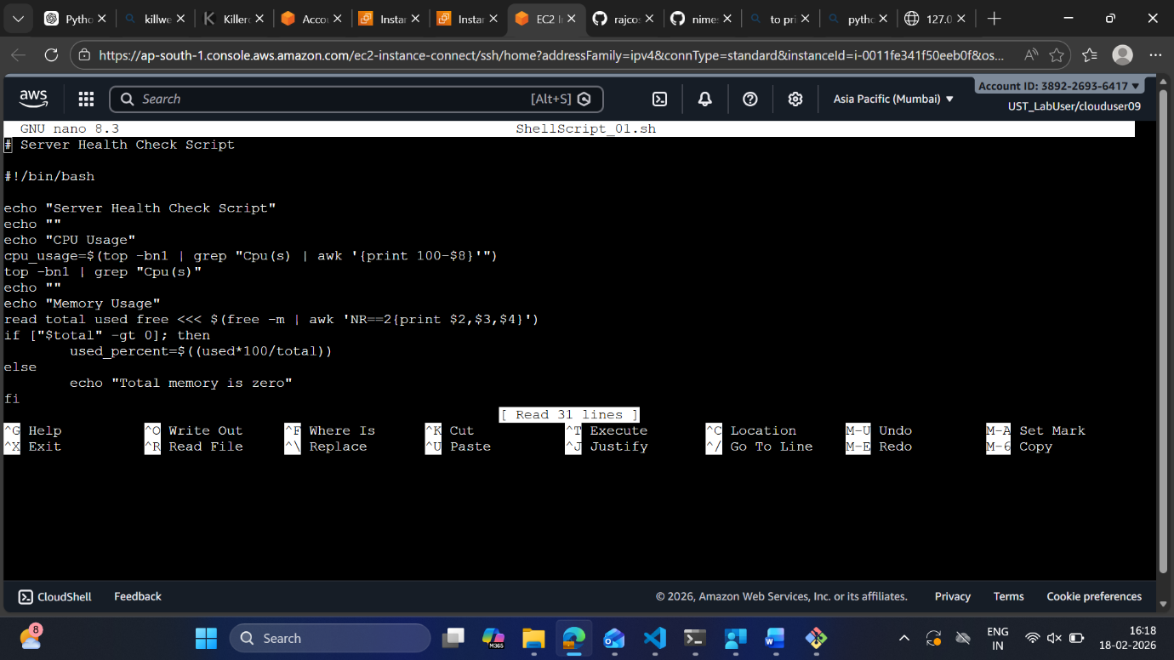

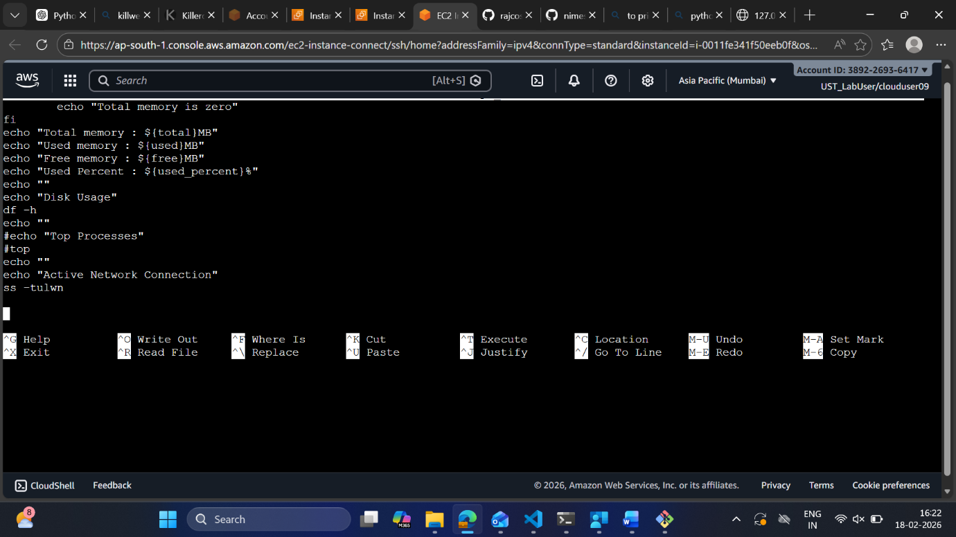

Here, we are here to check server health by analysing CPU usage,memory usage,Disk usage,Top processes and Active network connections.

- Disk Usage Alert Script

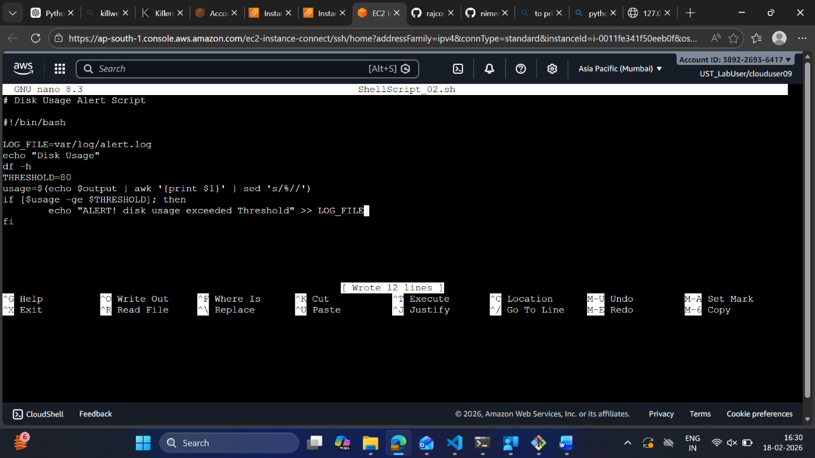

Here,we are displaying disk usage and also setting threshold,whenever disk usage crosses the threshold,it will log the Alert message to LOG_FILE.

